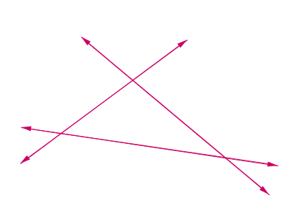 | Math Worksheets - Triangles
- Name the shape formed?
- How many vertices?
- How many sides?
- How many angles in all?

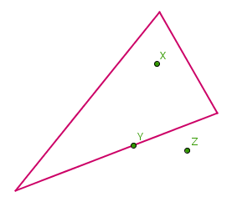
Say true or false

  - Point X is on the triangle.
  - Point Y is interior of the triangle
  - Point Z is exterior of the triangles
  - Point Y is on the triangle
 | 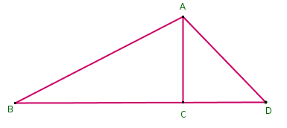 | - Identify three triangles in the figure.  - Write the names of seven angles.  - Write the names of six line segments.  - Which two triangles have B as common?
Name the type of triangle where:
  - All sides of the triangle are equal.
  - Two sides of the triangle are equal.
  - Each side of the triangle is of different length.

Name the type of triangle where:
  - Each angle is less than 90º.
  - One angle is greater than 90º
  - One angle is equal to 90º
Name the types of the following triangles:
a. Triangle with lengths of sides 7 cm, 8 cm and 9 cm.
b. ΔABC with AB = 8.7 cm, AC = 7 cm and BC = 6 cm.
c. ΔPQR such that PQ = QR = PR = 5 cm.
d. ΔDEF with m/_D = 90º.
e. ΔXYZ with m/_Y = 90º and XY = YZ.
f. ΔLMN with m/_L = 30º, m/_ = 70º and m/_N = 80º.
Match the following.
- 3 sides of equal length | a. Scalene
- 2 sides of equal length | b. Isosceles right angled
- All sides are of different lengths | c. Obtuse angled
- 3 acute angles | d. Right angled
- 1 right angle | e. Equilateral
- 1 obtuse angle | f. Acute angled
- 1 right angle with two sides of equal length | g. Isosceles

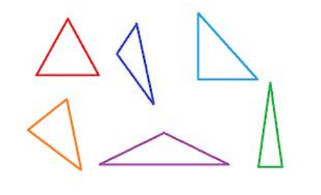
Name each of the following triangles in two different ways. You may judge the
measures of sides and angles or actually measure them.

What can you say about angles in Triangles in which

- all sides are equal?

- two sides are equal?

- all sides are different ?

What can you say about sides in a triangle:

- The side opposite to greatest angle?

- The sides opposite to equal angles?

- Side opposite to smallest angle?
Name the following :
- largest side
- largest angle
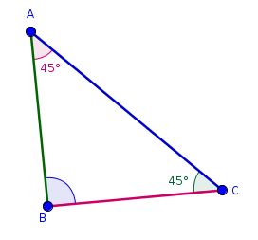
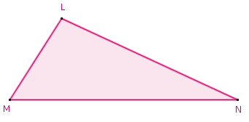
- smallest side
- smallest angle

 | Find the value of angle CAB
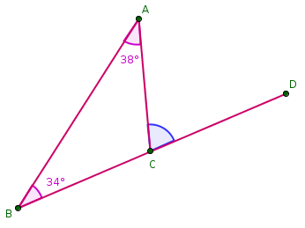
What is angle DCA called? Find its measure.

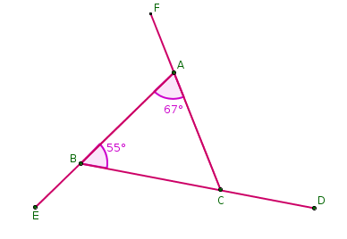
Name all exterior angles in the given diagram. Calculate all angle measure

