Section 1 : Playing with numbers on a number line

1. Look at the image below and answer the questions.

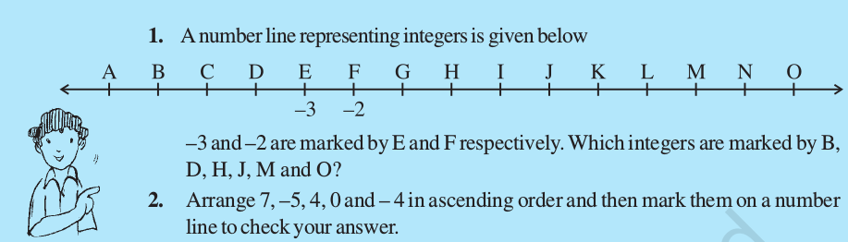

2. Can you find a pattern for each of the following? If yes, complete them:
(a) 7, 3, – 1, – 5, _____, _____, _____.
(b) – 2, – 4, – 6, – 8, _____, _____, _____.
(c) 15, 10, 5, 0, _____, _____, _____.
(d) – 11, – 8, – 5, – 2, _____, _____, _____.

3. Solve the problem below.
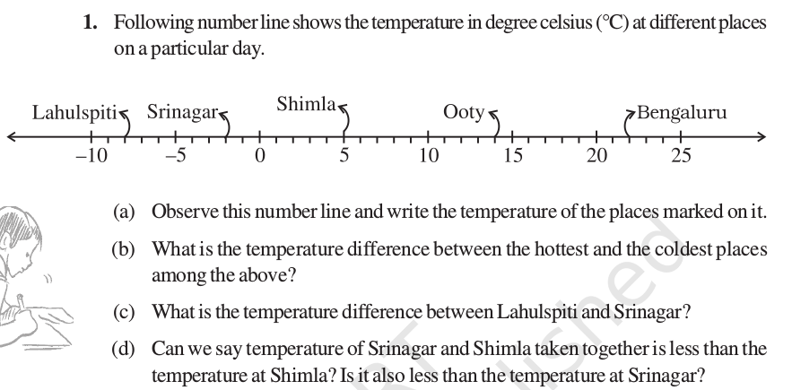
Word problems involving negative integers

4. Mohan deposits Rs 2,000 in his bank account and withdraws Rs 1,500 from it, the next day. If withdrawal of amount from the account is represented by a negative integer, then how will you represent the amount deposited? Find the balance in Mohan’s account after the withdrawal.

5. Afza goes 20 km towards east from a point A to the point B. From B, she moves 30 km towards west along the same road. If the distance towards east is represented by a positive integer then, how will you represent the distance travelled towards west? By which integer will
you represent her final position from A?

6. State whether the following statements are correct or incorrect. Correct those which
are wrong:
(i) When two positive integers are added we get a positive integer.
(ii) When two negative integers are added we get a positive integer.
(iii) When a positive integer and a negative integer are added, we always get a negative
integer.
(iv) Additive inverse of an integer 8 is (– 8) and additive inverse of (– 8) is 8.
(v) For subtraction, we add the additive inverse of the integer that is being subtracted,
to the other integer.
(vi) (–10) + 3 = 10 – 3
(vii) 8 + (–7) – (– 4) = 8 + 7 – 4

Also give examples in support of the statements – the correct statement or the corrected statement.

7. Solve the problem below.
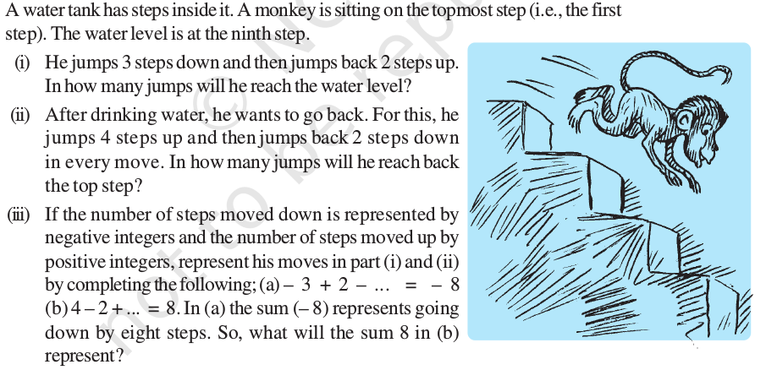

8. Verify a – (– b) = a + b for the following values of a and b.
(i) a = 21, b = 18
(iii) a = 75, b = 84
(ii) a = 118, b = 125
(iv) a = 28, b = 11

9. Use the sign of >, < or = in the box to make the statements true.
(a) (– 8) + (– 4) (–8) – (– 4)
(b) (– 3) + 7 – (19) 15 – 8 + (– 9)
(c) 23 – 41 + 11 23 – 41 – 11
(d) 39 + (– 24) – (15) 36 + (– 52) – (– 36)

10. Play the game of multiplication of integers.
(And state the rule for multiplication of integers)

Challenge yourself!!

1. Write a pair of integers whose sum gives
(a) a negative integer (b) zero
(c) an integer smaller than both the integers.
(e) an integer greater than both the integers. (d) an integer smaller than only one of the integers.

2. Write a pair of integers whose difference gives
(a) a negative integer.
(c) an integer smaller than both the integers.
(e) an integer greater than both the integers.
(b) zero.
(d) an integer greater than only one of the integers.

3. Discuss in your group and write the answers:
(i) The product (–9) × (–5) × (– 6)×(–3) is positive whereas the product
(–9) × ( –5) × 6 × (–3) is negative. Why?
(ii) What will be the sign of the product if we multiply together:
(a) 8 negative integers and 3 positive integers?
(b) 5 negative integers and 4 positive integers?

