Learning Digital Story Telling

Table:
Licensing information for this document.
The author of the document ‘Learning Digital Story Telling’ is Gurumurthy, IT for Change.
The document is licensed under the Creative Commons Attribution licence – CC BY.

Why Digital Story Telling
Everyone has many powerful stories to tell. Using digital technologies, a teacher can create a compelling story about an issue or an event, which can help students to get a richer and deeper idea. Digital stories make a teacher a ‘creator’ of educational resources, than only a ‘consumer’ of resources created by others.
In this resource book, the focus is to learning to develop a digital story for a teaching-learning situation. The digital story will cover the activities - creating a photo essay for documenting interactions with a community institution, an audio recording and finally creating a video, using the images and the audio.

Objectives
- Capturing information in non-textual ways; what to use when
  - Combining text, graphic and audio visual methods, developing a story and scripting by combining multiple digital methods; digital stories can be story books; audio or video
- Digital stories for communication in classrooms; in the case of language teaching-learning how this can be used for learning and assessment
- Evaluation of digital stories (for teachers for assessment)
- Possibilities for inclusion using digital story telling (for teachers for children with different learning needs and abilities)

Introduction to Digital Story Telling
The focus of this OER is to develop a digital story for different teaching-learning situations, using examples such as creating a photo essay for documenting an event or a place, comic strips to tell a story (graphic novels) and an audio recording for sharing understanding. The focus on all of these activities is to demonstrate possibilities of using digital stories to express understanding and learning without focusing exclusively on text based methods.

Creating a simple text story
You can use a text editor such as LibreOffice Writer to write your story.

Concept map on ‘Digital Story Telling’
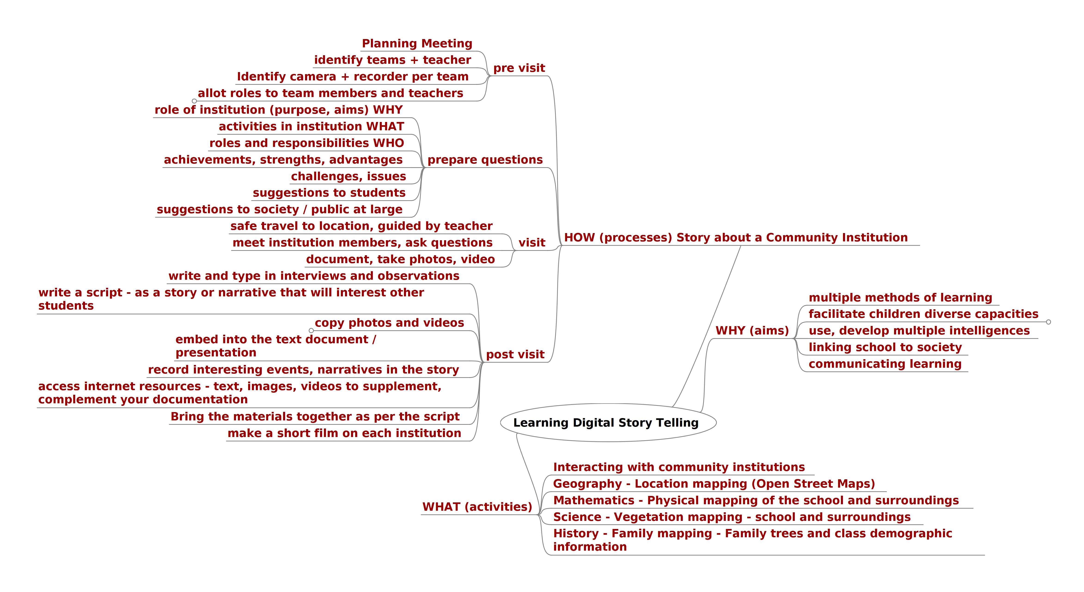

Interview with an expert on digital storytelling
An interview with an expert on digital storytelling is available here

