Table of Contents
Levels 2
Teaching Activity – 1 – Introduction to Number Line 2
Using Number Line for Addition (starting from 0) 2
W - Addition is going forward 3
W - When you add 1 where do you go? (with and without number line) 3
Teaching Activity 2 - Place Value Introduction 3
Making hundreds, tens and ones 3
Abstraction from here 3
Teacher reading material for place value stories 4
Worksheets with additions 4
W – Adding horizontally, vertically 4
W - Single digit and double digit – carry forward upto 999 4
W - Tux Math lessons 4
W - Additive Identity – Adding zero 4
W - Number combinations 4
Assessment Activity (Making 10) – Annexure 5
Assessment Activity (Counting in a grid) - Annexure 5
Addition as Counting Forward 5
Using Number Line for Subtraction (starting from 0) 5
Subtraction is going backward 5
When you subtract 1 where do you go? 5
Single digit and double digit without borrowing 5
Subtracting horizontally: 5
Subtracting vertically 5
Tux Math lessons 5
Subtracting the number itself 5
Test 1 – Solve the Number Bonds 5
Addition 5
Subtraction 5
Tux Math lessons 5
Notes 5
Test 2 – Write Missing Numbers to make a given total 5
Introduction to negative numbers 6
Teaching activity – 2 6
Using Number Line for Addition (starting from 0) 6
Addition is going forward for positive numbers, but going backward for negative numbers 6
When you add -1 where do you go? (with and without number line) 6
Single digit and double digit – no carry forward 6
Adding horizontally: 6
Adding vertically 7
Tux Math lessons 7
Using Number Line for Subtraction (starting from 0) 7
Subtraction is going backward for positive numbers; going forward for negative numbers 7
When you subtract -1 where do you go? 7
Single digit and double digit without borrowing 7
Subtracting horizontally: 7
Subtracting vertically 7
Subtracting the number itself 7
Activity 1 (Making 10) – Level 1 7
Activity 2 – Make Number Line 8
Activity 3 Adding and subtracting in a grid 8
Activity 4 – Make numbers 9
Tests 10
Test 1: Number Bonds Addition 10
Test 2: Number Bonds Subtraction 10

Levels
Level | Class | Topics | To include
1 | 2-3 | Shapes and Symmetry; Visualization through Free Drawing  Estimation and time sense; calendar  Weights | Not included
 |  | Place Value upto Hundreds and number names | Included
 |  | Understanding cardinal and ordinal numbers | Included
 |  | Understanding and interpreting word problems | Included
 |  | Two-digit addition and subtraction (with carry over not exceeding hundredth place value) | Included
 |  | Multiplication as repeated addition – numbers, words (with with carry over not exceeding hundredth place value) | Included
2 | 4-5 | Patterns and tessellations; Top, side, front views  Heights and lengths, Time  Measures (weights and volumes) | Geogebra files included
 |  | Multiplication, divisibility, division, commercial arithmetic | Included
 |  | Introduction to circles (different ways of drawing a circle, use of compass) | Not inclued
 |  | Area and perimeter | Not inclued
 |  | Fractions | Included
3 | 5-6

Teaching Activity – 1 – Introduction to Number Line

Using Number Line for Addition (starting from 0)
Number line activity to be done in class with positive numbers and then followed with this set of worksheets. Make 2x2 sets of numbers – positive and negative - (-7,-6,-5,.....,5,6,7,8,9,10)
Steps in activities/ assumptions of learning
1. Ask them to arrange the 1st set of cards. Give them positive numbers in the first activity. | 1. They should know the increasing order of number line  2. We know that they are familiar with number line  3. When you add 1, where do you go?  4. When you add 0, where do you go? (Additive identity)
2. Ask children to move places along the number line by adding positions; by subtracting positions | 1. Addition of positive numbers  2. Subtraction of positive numbers  3. Addition and subtraction are opposite operations  4. They should formulate this as a word problem

W - Addition is going forward

W - When you add 1 where do you go? (with and without number line)

Teaching Activity 2 - Place Value Introduction

Making hundreds, tens and ones

- Print 32 squares of this.
- Distribute into 8 groups of 4 children each.
- Each group will get 4 squares.
- The value of 4 squares will be 4x100 = 400
- Each group must cut the solid lines; 1 square will have 10 strips. These are tens. So each square has 10 “tens” (They can either cut, or work without cutting – up to the children)
- Each one of those tens will have 10 ones.
- Let the children make numbers and write them down
- Ask them what is the largest number each group can make? 400 is the answer – but check if children understand this.

Abstraction from here
Now let us assume children have 9 such squares.
In each group, how many hundreds are possible ? – 9
In each group, how many tens are there ? – 9 x 10 = 90
In each group, how many tens are there ? – 90 x 10 = 900

1-9 ones are possible; 10 ones means one ten. Ten ones is the same as one ten
1-9 tens are possible; 10 tens means one hundred. Ten tens is the same as one hundred.
What happens when we have 10 hundreds? What is it the same as?

What is the importance of ten? We count in groups of tens
9+1= 10 = 10 x 1
99 + 1 = 100 = 10 x 10
999 + 1 = 1000 = 10 x 100
Greatest 1-digit number + 1 = Smallest 2-digit number
Greatest 2-digit number + 1 = Smallest 3-digit number
Greatest 3-digit number + 1 = Smallest 4-digit number
Following the pattern, we can expect that, on adding 1 to the greatest 4-digit number
(9999 – nine thousand nine hundred and ninety nine) we get the smallest 5-digit number
(9999 + 1 = 10,000 or ten thousand). Further we can expect that 10 x 1000 = 10,000 i.e.
9999 + 1 = 10,000 = 10 x 1000.

Teacher reading material for place value stories
http://www.math.wichita.edu/history/topics/num-sys.html#sense
Write on the board like this (for advanced students):
Hundreds | Tens | Ones | Number | Comments
3 | 8 | 3 | 383 | Watch if students are stating numbers are correct
4 | 7 | 2 |  | Watch if students are stating numbers are correct
0 | 3 | 5 |  | Ask how many hundreds there are? They should say this number is less than hundred
1 | 10 | 5 |  | Do they say 205? What is the answer?
2 | 8 | 3 |  | Without forming the number can they say if number >200? Can they say if this is greater than number below?
2 | 7 | 5 |  | Without forming the number can they say if number >200?
 | 10 | 7 | 3 | What is the answer here?Point out “regrouping”. This is important for addition/ subtraction
 | 11 | 8 | 2 | What is the answer here? Think about how students are doing 10 hundreds plus 1 hundred. Point out “regrouping”. This is important for addition/ subtraction
1 | 7 | 4 | 3 | What is the number here?

Worksheets with additions

W – Adding horizontally, vertically
Worksheet: One digit addition horizontally and vertically
Worksheet: Two digit addition - Arrange vertically and add
Worksheet: Three digit addition horizontally and vertically

W - Single digit and double digit – carry forward upto 999
Worksheet: One digit addition
Worksheet: One digit addition of 3 numbers
Worksheet: Two digit addition
Worksheet: Three digit addition - Arrange vertically and add

W - Tux Math lessons

W - Additive Identity – Adding zero

W - Number combinations
Worksheet: Number combinations 1 to 6
Combinations of 1, Combinations of 2…....Upto 9

Assessment Activity (Making 10) – Annexure

Assessment Activity (Counting in a grid) - Annexure

Addition as Counting Forward

Using Number Line for Subtraction (starting from 0)

Subtraction is going backward
Worksheet: Subtraction as counting backward

When you subtract 1 where do you go?
Worksheet: Subtracting the number itself and previous number

Single digit and double digit without borrowing

Subtracting horizontally:
Worksheet: Horizontal subtraction 1
Worksheet: Horizontal subtraction 2
Worksheet: Horizontal subtraction 3

Subtracting vertically
Worksheet: Subtraction with borrowing

Tux Math lessons

Subtracting the number itself
Worksheet: Subtracting the number itself and previous number

Test 1 – Solve the Number Bonds
Worksheet: Number bonds

Addition

Subtraction

Tux Math lessons

Notes
Before they move to Level 2 (with carry forward, borrowing and three digit numbers, students must finish Level 1 and 2 of place value materials (upto making numbers upto 100)

Test 2 – Write Missing Numbers to make a given total
Worksheet: Two digit addition find missing numbers

Introduction to negative numbers
Number line activity to be done in class with positive and negative numbers and then followed with this set of worksheets.

Teaching activity – 2
1. Ask them to arrange the 1st set of cards. Give them positive numbers first and then negative numbers | 1. They should know the increasing order of number line  2. We know that they are familiar with number line
2. Ask children to move places along the number line by adding positions; by subtracting positions | 1. Addition of positive numbers  2. Subtraction of positive numbers  3. Addition and subtraction are opposite operations  4. They should formulate this as a word problem
3. Introduction of operations of negative numbers | 1. Negative numbers are opposite of positive numbers  2. They do the opposite; when you add a negative number, you go backward in the number line  3. When you subtract a negative number, you go forward.  4. Distinguish between  5 – 3 and 5 + (-3)  5. Show the operations on negative numbers (addition, subtraction, multiplication if possible)

Using Number Line for Addition (starting from 0)

Addition is going forward for positive numbers, but going backward for negative numbers

When you add -1 where do you go? (with and without number line)

Single digit and double digit – no carry forward

Adding horizontally:

Adding vertically

Tux Math lessons

Using Number Line for Subtraction (starting from 0)

Subtraction is going backward for positive numbers; going forward for negative numbers

When you subtract -1 where do you go?

Single digit and double digit without borrowing

Subtracting horizontally:

Subtracting vertically

Subtracting the number itself

Activity 1 (Making 10) – Level 1
Look at the numbers in the given grid. Some pairs of numbers add upto 10. Find atleast 5 of them and circle them. One example is given.
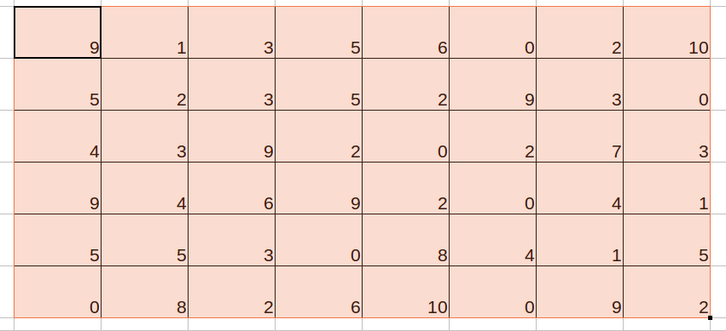

Activity 2 – Make Number Line
1,2,.......
10,20,.......
100, 200,.....

Activity 3 Adding and subtracting in a grid

Activity 4 – Make numbers
(stop the activity at 999 and not go to 1000 place ; and move according to difficulty)
- Arrange in order – shortest, tallest, increasing and decreasing order
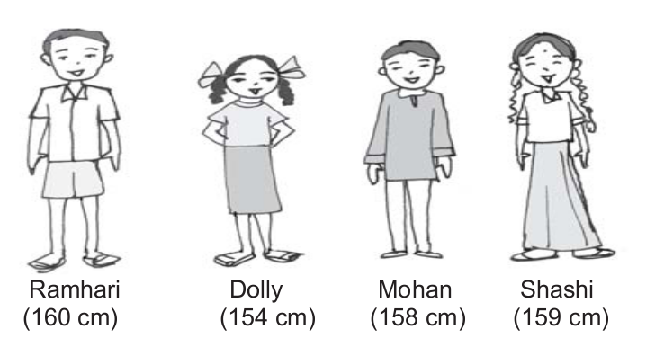

- Making numbers
Suppose we have 4 digits 7, 8, 3, 5. We want to make different 4-digit numbers using these digits such that no digits are repeated in each number. For example, you can make 7835 and 3578 but 7738 is not allowed because 7 is repeated and 5 is not used.
a. What is the greatest number you can make?
b. What is the smallest number?
c. Can you write down how you make the greatest number and the smallest number?
Use the given digits without repetition and make the greatest and smallest 4-digit numbers. Note that 0753 is a 3 digit number and is therefore not allowed.

Digits | Greatest | Smallest
2,8,7,4
9,7,4,1
4,7,5,0
1,7,6,2
5,4,0,3

3. Now make the greatest and smallest 4-digit numbers by using any one digit twice.
Hint: Think about which digit you will use twice.
Digits | Greatest | Smallest
3,8,7
9,0,5
0,4,9
8,4,1
5,4,0,3

4. Make the greatest/ smallest 4-digit numbers using any 4 different digits with conditions as given
Digits | Greatest | Smallest
Digit 7 is always at the ones place
Digit 4 is always at the tens place
Digit 9 is always at the hundreds place
Digit 1 is always at the thousands place

Tests

Test 1: Number Bonds Addition

Test 2: Number Bonds Subtraction

